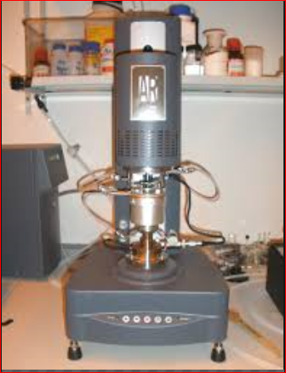

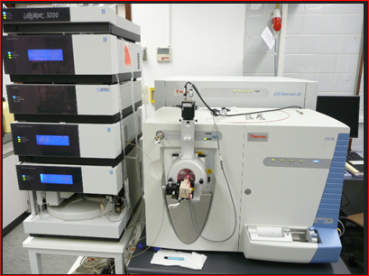

**ESI Electrospray Mass Spectrometer**

**TA Instruments Rheometer AR2000ex**